Poppy & Max and the Noisy Night
Reading Activity Guide

Before Reading(책을 읽기 전에 표지를 보면서 묻고 대답해 봅니다.)
- What do Poppy and Max look like?
- They look scared / frightened / worried, etc. (복수 답 가능)
- Have you ever heard any strange noise at night? What was it?
- I heard a rumble of thunder / the sound of wind / knocking on the door, etc. (복수 답 가능)

During Reading(오디오를 듣거나 책을 읽으면서 중간중간에 나눌 수 있는 질문들입니다.)
- What game did Poppy and Max play together sitting by the fire? (p.5-7)
- Snap
2. What was Max scared of? (p.10)
- Lightning
3. What made Max leap onto Poppy’s lap? (p.12)
- A rumble of thunder
4. Why did Max howl and burrow under the cushions? (p.14)
- He was very scared of thunder and lightning.
5. What sound woke Poppy & Max? (p.18)
- A loud bang
6. Where did Poppy tell Max to go and look? (p.19)
- Downstairs
7. What did they find in the kitchen? (p.21)
- They found a picture had fallen from the wall.
8. What sound woke Poppy & Max this time? What was it? (p.22-25)
- A loud thump / The soap had fallen into the bath.
9. Where did the rustling sound come from? (p.26)
- It came from under the bed.
10. Who was scared of the mouse? Who wasn’t? (p.26-29)
- Poppy was very scared of the mouse but Max wasn’t.

After Reading(책을 다 읽은 후 아이와 함께 할 수 있는 주제/내용 관련 독후활동으로, 1번은 유치-
초등저학년, 2번은 초등 3, 4학년 이상의 내용입니다.)
- Who is scared of what? Fill in the speech bubbles based on the story.
(누가 무엇을 무서워했는지 말풍선 안에 대사로 적어보기)
- Sequencing Chart: fill in the chart based on the story.
(일어난 사건들을 시간 순서대로 나열해 보고 이를 토대로 스토리 요약하기)

**1, 2번 활동지가 뒷장에 첨부되어 있습니다.**

Who is scared of what? Fill in the speech bubbles based on the story.

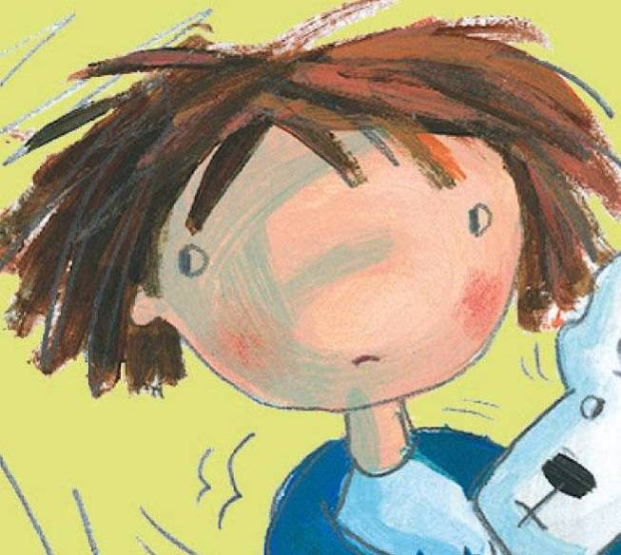
I am scared of
________.

I am scared of
_______ and _______.

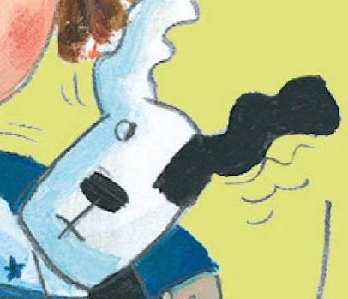

What are you scared of? Write and say.

I am scared of ___________________
_________________________________.

Sequencing Chart: fill in the chart based on the story.
.
What was the Noise from Where?
The first sound was… | It was from… | It was a …
a loud BANG! | downstairs

The second sound was… | It was from… | It was a …
The last sound was… | It was from… | It was a …

Have you ever heard any strange noise at night? Fill in the chart based on your
own experience.
The sound was… | It was from… | It was a …

